Introduction

Purpose:
Our Initial Value Proposition (IVP) is that business, researchers, Post-Secondary Institutions (PSIs), private labs and government groups (funders, labs etc) have no centralized, well-developed method of matching solution providers with solution seekers.

Scope:
The platform will contain data on resources, (talent, space, equipment, software and hardware solutions / products) which will be matched with well-defined projects needing a solution.

System Requirements

Functional Requirements:

To support the user stories, our application has the following requirements. Others may exist, but we’ve identified and organized as many as possible here. This section summarizes the key components.

SP.FR.001 Navigation
The application must be able to provide navigation as described in the Application Design section above or in the design specification document created by the designer.

SP.FR.002 Login
Users must log in to the application using an email address and password. Password requirements should follow as reasonably possible the current best practices the Open Web Application Security Project (OWASP) specifies.

SP.FR.003 Forgot Password Process
Users who forget their passwords can recover it using the side channel token methodology (link via email). For the purposes of the MVP we can skip the first step of identity confirmation using security questions as detailed in the specification linked above.

SP.FR.004 User Profile Editing
Logged-in users will be able to edit the content of their user profiles
- Name
  - First name
  - Last Name
- email address
- Office phone number
  - Field must allow for all different telephone number types to include country codes - for example +011, +1, etc
- Education
  - More than one field as some users may want to add several degrees to their profile
- Position (and any role-relative specifics)
- Languages spoken
- Experience Level (Junior / Senior / Expert)
- Categories of experience (as with profile creation on work-share communities, user will being typing and will be able to select from proffered choices) - industry classifications to be derived from Standard Industrial Classifications https://en.wikipedia.org/wiki/Standard_Industrial_Classification

SP.FR.005 Application Design
Elements of application design will be as shown in the wireframes or the design specification document. We will require a responsive design layout. We intend to support desktop, laptop and tablets.

SP.FR.006 User Administration Dashboard (Admin)
The technical nature of the platform and its' user match-making process requires some level of admin oversight. This process needs a user administration dashboard to input user details and initiate the invitation process.

Non Functional Requirements:

Performance :- The website’s load time should not be more than one second for users.

Reliability :- Applicants can be able to access the website without failure.

Availability :- In case of unplanned system downtime, all features will be available after one working day.

Recoverability :- If the major incident happens on the website, it must take measures to go back to being fully operational within three days.

Usability :- The website’s interface has to be user friendly and easy to use.

System Requirement

GCP(Google Cloud Platform) :-

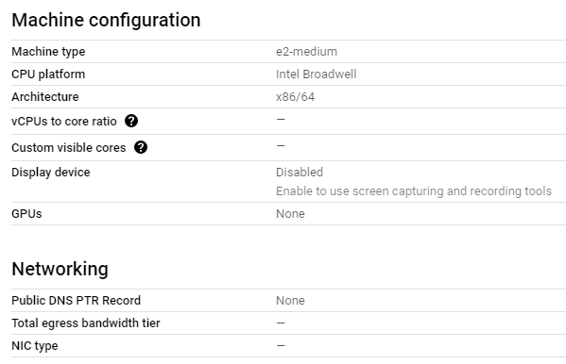
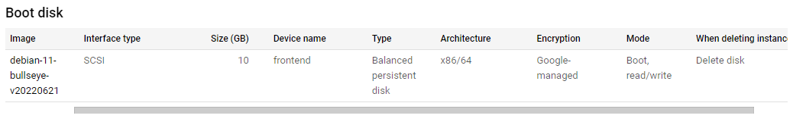
There are 3 VM’s with the same above given configurations :-
- Dev
- Alpha
- Beta

Cloudflare :-

To use Cloudflare, you need to point the name servers for your domain to Cloudlare's ones.
The traffic is forwarded to the Cloudflare network, where it gets automatically filtered o prevent malicious traffic.
The name servers can be changed where you have registered the domain.

Cloudflare Name Servers:
NS ara.ns.cloudflare.com
NS chris.ns.cloudflare.com

DNS Record:
CNAME - www - thesciencepark.dev - Proxied - TTL(Auto)
A - thesciencepark.dev - 68.183.192.104 - Proxied - TTL(Auto)
A - alpha - 34.69.195.100 - Proxied - TTL(Auto)
A - beta - 34.172.105.190 - Proxied - TTL(Auto)
A - dev - 35.184.8.213 - Proxied - TTL(Auto)

SSL/TLS encryption mode is Flexible (Encrypts traffic between the browser and Cloudflare)

